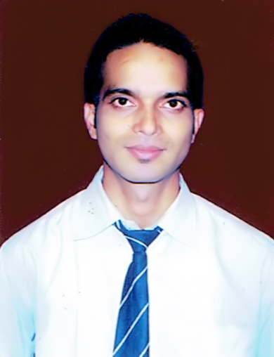

Himanshu Kumar Singh
Phone No.: +917209847939 /+917004524030
E-Mail: himanshusingh.bca@gmail.com

Seeking assignments in Sales and Marketing, Business Development and Channel Management with a reputed organization.

To utilize my all management skills for achieving the target and developing the best performance in the organization. I would like to implement my innovative ideas, skills and creativity to achieve the goal.
Location Preference: Anywhere in India.

Profile Snapshot

- MBA (Marketing/HR) with nearly 2 years of experience in Sales & Marketing, Business Development, Team Management and Channel Sales Management.
- Proficient at analyzing market trends to provide critical inputs for business development initiatives and formulation of selling & marketing strategies.
- An effective communicator with excellent planning & coordination skills.

Areas of Expertise

Sales & Marketing
- Managing the sales and marketing operations and accountable for increasing sales growth.
- Conducting detailed market study to analyze the latest market trends and tracking competitor activities.

Distributor/ Channel Management
- Identifying and networking with financially reliable dealers & channel partners, resulting in deeper market penetration & reach.
- Evaluating performance & monitoring distributor sales and marketing activities.

Business Development
- Developing marketing plans designed to assure achievement of agreed volume, market share and profit objectives.
- Implementing strategies for acquiring business from clients and effectively using the potential of existing accounts.

Work Experience
- Currently Working in SMV Beverage Pvt Ltd./Pepsi, Dhanbad (Jharkhand) Covering 3 distributor as a “Customer Executive”.
- Since Oct’11 till September 2012 Kolkata weir industries ltd, Dhanbad (Jharkhand) as a “Business Development Officer”.
Role-Generate new lead and increase the sale.
- Since March’11 till Aug 2011 Tech Mahindra, Kolkata (WB) as “Customer Support Associate”.
Role- Handled Customer Dispute.

Achievements
.
- I have done Dissertation programme “To Study the spending pattern of children and their influences on various product categories.” (High, medium and low – involved products) with special reference to the city of Rourkela odisha.
- Had worked as a volunteer in college event like QUEST 15-16 and Marketing Mela.
- Had won basketball and kabbadi match in college athletic meet.

Summer Internship project

SMV Beverage Pvt Ltd (Jamshedpur) as summer trainee.
Project Title – Comparative Study on Mango Drink Regards to Slice and Maaza.

Education

2016 MBA (Marketing & HR) from RIMS (Rourkela), BPUT (Odisha). (7.5CGPA)
2008 BCA from Sikkim Manipal University (SMU), Sikkim. (70%)
2005 12th Standard from Anup Singh Inter College, (Gaya, Bihar) BSEB. (47%)
2003 10TH Standard from Zila School (Dhanbad, Jharkhand) JSEB. (51%)

IT Skills

Operating Systems : Microsoft Windows: XP.
Packages : Microsoft Office (Excel, Word, Access, PowerPoint).
Concepts : Internet Applications.

Interests

Visiting different Markets, Communicating and learning market experiences.

Personal Details

Date of Birth : 25th January 1989
Father’s Name : Mr. Shailendra Kumar Singh
Correspondence : Bungalow No3 Tata Sijua, P.O.-Bhelatand,
Address P.S.-Jogta, Dist.- Dhanbad, Jharkhand.
Gender : Male
Marital Status : Single
Languages Known : English, Hindi, and Bojpuri.

Declaration: -
I hereby affirm that the information furnished in this form is true and correct to the best of my knowledge and belief.
Signature

